
DURING YOUR WHOLE BLOOD DONATION Try these tips to stay well

After your arrival
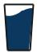

Drink 2 glasses of water (approx. 500ml)

On the couch

Do these muscle exercises before the needle goes in or comes out, before getting up, or if you feel dizzy, hot or nauseous.
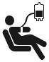
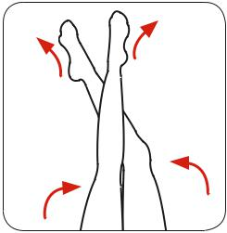

1. Cross your legs

2. Squeeze your inner thigh

and abdominal muscles

- Stretch your ankles

Hold for 5 secs, then relax 5 secs.

Repeat 5 times then switch legs.

Enjoy

Yourself!

- Watch TV

- Read

- Listen to music

- Talk to a staff
- Use free Wi-Fi

If you feel uncomfortable or anxious at any time, tell a staff member.


AFTER YOU DONATE Thank you! Look after yourself today.

Straight after

Drink 2 glasses of water (approx. 500ml) in the first hour after donating.


Relax for 15-20 mins in our refreshments area.

For the next 6 hours

Do

Drink at least 3 glasses of water in the next 3 hours


Eat regular meals

Don’t
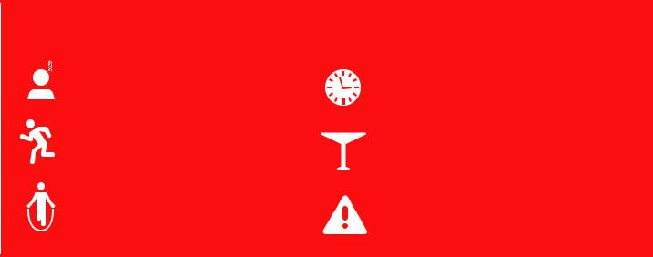

Have a hot shower | Stand up for long
Rush around or walk | periods
for long periods | Drink alcohol
Do strenuous | Do strenous or hazardous
physical exercise | occupational activities

If you feel unwell

Lie down or sit down, and start doing muscle tensing exercises. Ask someone for help.
If you are driving, pull over, park immediately, and call for assistance.

